Directions to South Sound Autism Partnership (SSAP) Meetings on UW-Tacoma Campus
UW Autism Center Tacoma Office Line: 253-692-4711
LOCATION : Room 338A Cherry Parkes Building
Online map: http://www.tacoma.uw.edu/campus-map/campus-map
Physical Address:
UW Autism Center - Tacoma
McDonald Smith Building- rm 110
Tacoma, WA 98402-3100

Mailing Address:
UW Autism Center - Tacoma
Box 358455
1921 Pacific Avenue.
Tacoma, WA 98402-3100

DRIVING DIRECTIONS
From Interstate 5: Take Exit 133. Take right ramp for I-705 N toward Tacoma City Center exit. From I-705 take the South 21st Street exit. Turn left at the traffic light onto 21st Street. Keep straight onto S. 21st St. You will pass Pacific Avenue and then take the next right onto Dolly Roberson Lane. The Tacoma UW Autism Center sponsors the South Sound Autism Partnership meetings which are located in room 338A of the Cherry Parkes Building. Please come into the lobby and make your way via elevator or stairs to the third floor. If you have any questions you can call our receptionist, Katy Parrish, at 253-692-4711.
PARKING

Parking lots and permits

There are five pay-parking lots and one pay-parking garage on campus; rates vary (typically $1.00 per hour). The closest parking to the Center is in the lot on C Street. There are also nearby pay parking lots on Pacific Avenue next to the Washington State History Museum and at Broadway and 17th next to the Tacoma Convention Center.

See map below for parking lot locations.

Street parking

Metered street parking is available on campus with a two-hour limit. Some free parking is available between Market Street and Tacoma Avenue from S. 21st to S. 17th streets.

MAP

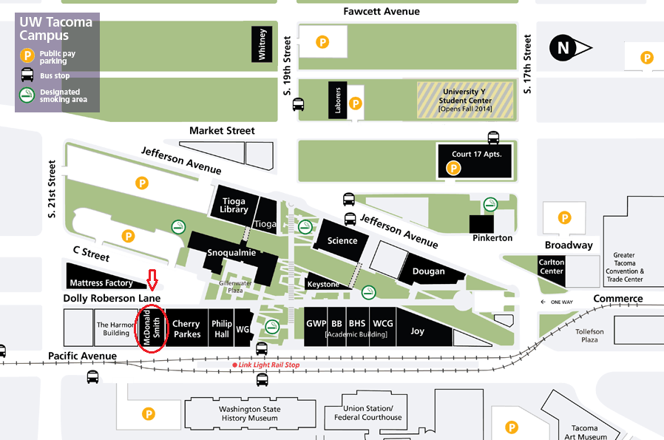

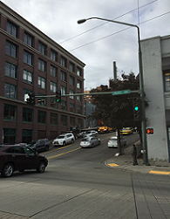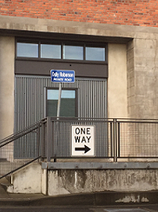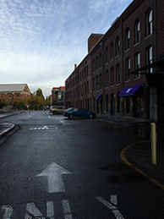
Heading up S. 21st St., continue past Pacific Ave.

Enter Dolly Roberson Lane (UWAC is located in the Cherry Parkes Bldg on right hand side)

Turn right onto Dolly Roberson Lane

